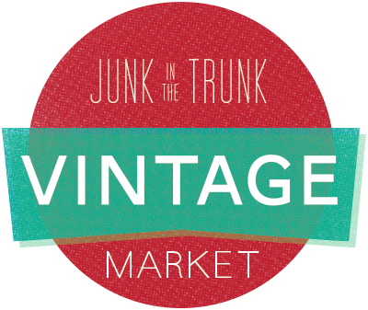 | MEDIA CONTACT:  Michelle Fortin  (480) 338-0331  Michelle@junkinthetrunkvintagemarket.com

Junk in the Trunk Vintage Market Adds Dates, Expands to California
The region’s largest vintage & handmade shopping event will be in Scottsdale in May and San Diego in July.
Monday, February 29, 2016

SCOTTSDALE, AZ: After welcoming a record 35,000 people to Junk in the Trunk Vintage Market in 2015, the Scottsdale-based business is announcing expansion plans for 2016. Vintage, antique and handmade shoppers across the Southwest will no doubt celebrate the growth of this unique weekend shopping experience. Market enthusiasts will enjoy an additional day to check out the event in Arizona, and out of state as the business expands to San Diego, California.

Junk in the Trunk Vintage Market can attribute its remarkable growth to careful attention in selecting only the finest vintage and handmade artisans, live performances from local musicians, and adding creative design themes to each market. Shoppers enjoy the atmosphere of these events as much as they treasure the one-of-a-kind finds from vendors.

“We anticipate this tremendous growth in our customer base to continue,” explains Lindsey Holt, Junk in the Trunk Vintage Market co-founder and owner. “Expanding what we offer is an exciting step. We feel privileged to host even more people looking to incorporate the vintage lifestyle.”

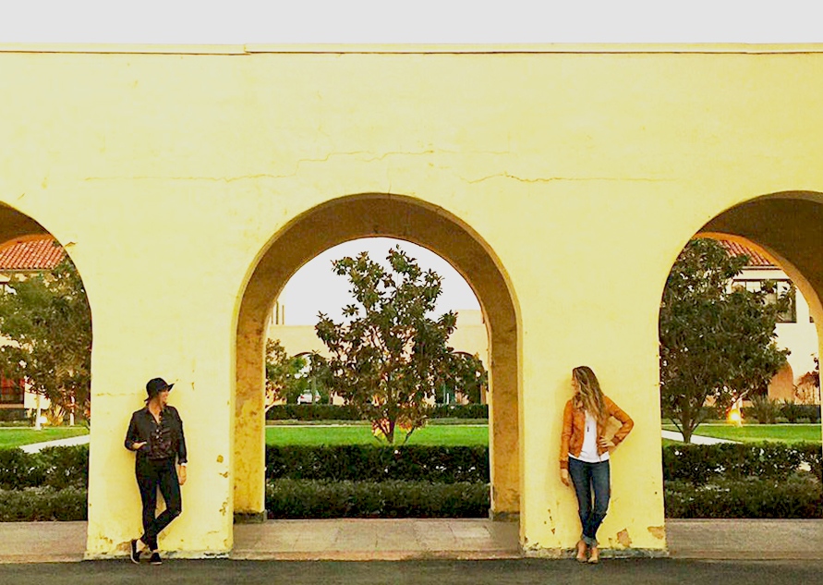
In Scottsdale, Arizona on Mother’s Day weekend, Junk in the Trunk Vintage Market is adding Friday night to the event lineup May 6-8, 2016 at WestWorld. Traditionally held on Saturday and Sunday, the added experience on Friday, May 6th from 6:00 to 9:00 pm allows junk-seekers first opportunity to purchase items from more than 200 vendors. Tickets will be sold in advance for $50 and will include a canvas bag, drink ticket and general admission re-entry for Saturday and Sunday. Online ticket sales begin March 1, 2016, at junkinthetrunkvintagemarket.com. General admission is Saturday and Sunday from 9:00 am to 4:00 pm and is $8.00 per person. Kids 12 and under are free.
Junk in the Trunk Vintage Market San Diego will take place the weekend of July 16-17, 2016, at Liberty Station, formerly the Naval Training Center, San Diego, which welcomed its first U.S. Navy recruits in 1923. The historical setting, now an outdoor space created to bring the community together, offers ample space, parking and a beautiful setting for shoppers.
“Hosting Junk in the Trunk Vintage Market in San Diego is a dream come true,” said Coley Arnold, Junk in the Trunk Vintage Market co-founder and owner. “We are thrilled to curate a vintage and handmade market for Southern California and look forward to offering an additional event this year for our loyal junkers.”
Coley Arnold (L) and Lindsey Holt at Liberty Station
For more information on Junk in the Trunk Vintage Market, a detailed list of vendors and additional information visit junkinthetrunkvintagemarket.com.
Junk in the Trunk Vintage Market inspires creativity
by curating spaces to embrace a vintage lifestyle.

junkinthetrunkvintagemarket.com

###

